Supplementary Material

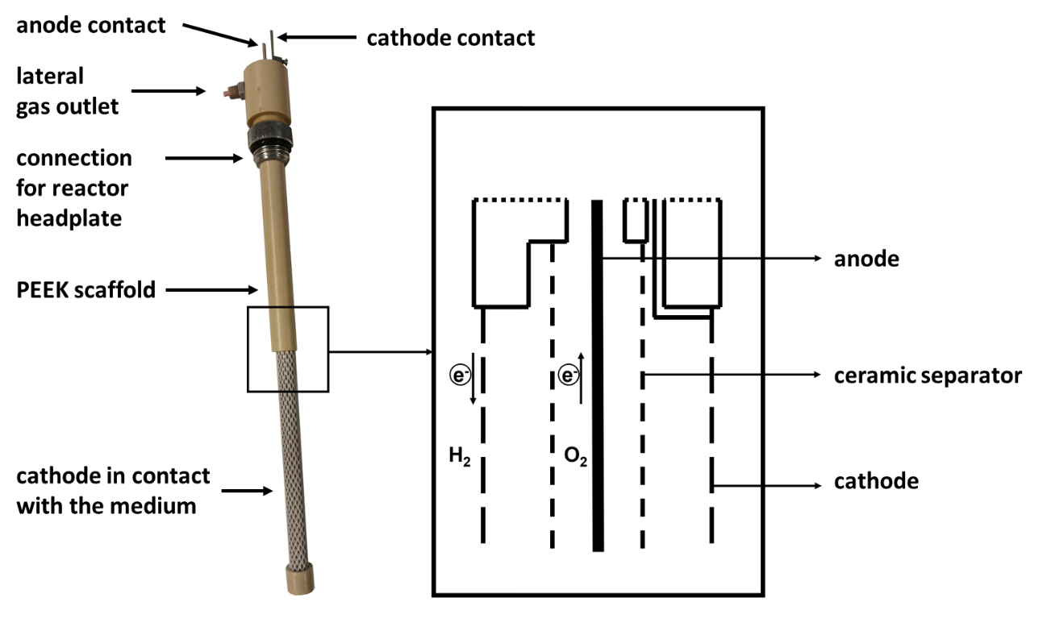
Figure S1: Simplified scheme of the All-in-One electrode for in-situ electrolysis (Herzog et al. 2022. Eng. Life Sci. 23, e2100169. doi:10.1002/elsc.202100169)

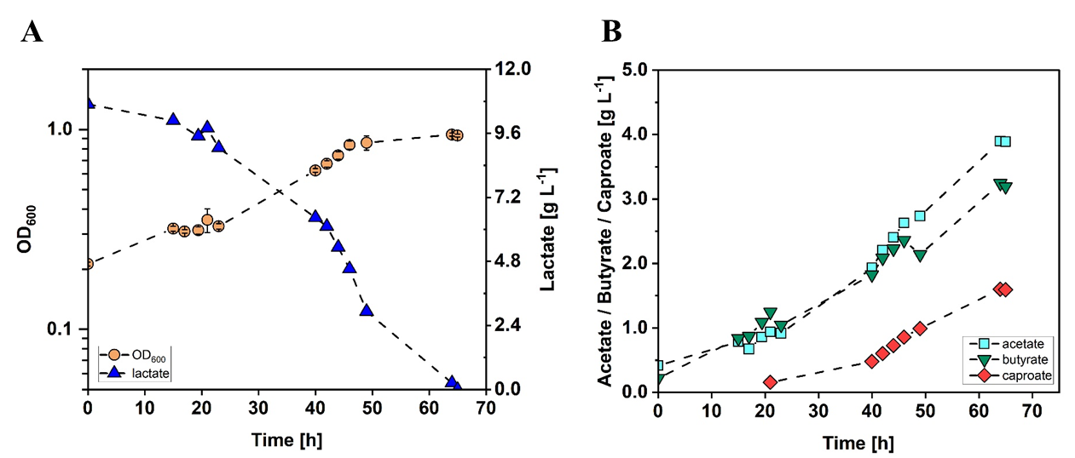
Figure S2. Stirred-tank batch cultivation of C. drakei with lactate as substrate.
(A) Optical cell density (OD₆₀₀, orange circles), lactate concentration measured in the medium (blue triangles); (B) acetate concentration (cyan squares), butyrate concentration (green triangles), caproate concentration measured in the medium (red diamonds). (T = 30 °C; pH = 7.0; P V⁻¹ = 0.04 W L⁻¹; F_{CO2} = 0.9 L h⁻¹; V₀ = 1.4 L).

