NMR relaxometry probes solvent-polarity-dependent molecular interactions in stimuli-responsive lyogels
Muhammad Adrian, *ª Kathrin Marina Eckert,^{b,h} M. Raquel Serial,^{a,c} Artyom Tsanda,^{d,e} Lukas Rennpferdt,^{g} Stefan Benders,^{a,h} Hoc Khiem Trieu,^{g} Tobias Knopp,^{d,e,f} Irina Smirnova,^{b,h} Alexander Penn^{a,h}
a] Institute of Process Imaging, Hamburg University of Technology
Denickestraße 17, 21073 Hamburg, Germany
b] Institute of Thermal Separation Processes, Hamburg University of Technology
Eißendorferstraße 38, 21073 Hamburg, Germany

c] Department of Process and Energy, Delft University of Technology
Leeghwaterstraat 39, 2628 CB Delft, The Netherlands

d] Institute for Biomedical Imaging, Hamburg University of Technology
Am Schwarzenberg-Campus 3, 21073 Hamburg, Germany

e] Section for Biomedical Imaging, University Medical Center Hamburg-Eppendorf
Lottestraße 55, 22529 Hamburg, Germany

f] Fraunhofer Research Institution for Individualized and Cell-based Medical Engineering IMTE
Mönkhofer Weg 239a, 23562 Lübeck, Germany

g] Institute of Microsystems Technology, Hamburg University of Technology
Eißendorferstraße 42, 21073 Hamburg, Germany

h] United Nations University Hub on Engineering to Face Climate Change at the Hamburg University of Technology, United Nations University Institute of Water, Environment and Health, Hamburg, Germany

Table S1. List of used chemicals.
Chemical | Purity | Supplier
N-isopropylacrylamide (NIPAM) | > 98% | abcr
N,N′-methylenebis(acrylamide) (MBA) | > 99% | Sigma-Aldrich
Ammonium persulfate | > 98% | Sigma-Aldrich
Sodium metabisulfite | > 97% | Honeywell Fluka
Butyl acetate | ≥ 99.5% | Supelco
Ethanol | ≥ 99.9% | Chemsolute

Table S2. Chemical structures of pNIPAM building blocks and organic solvents.
Component | Chemical structure
Monomer  (N-(propan-2-yl)prop-2-enamide) |  | 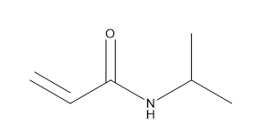
Ethanol |  | 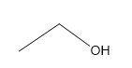
Butyl acetate |  | 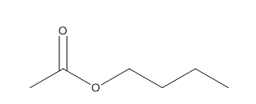

Table S3. IDACs, hydrogen bond interaction energies, and Van der Waals interaction energies of NIPAM monomer in organic solvents at infinite dilution¹.
Organic Solvent | IDACs, ln(γ_{ᵢ}∞) | Hydrogen bond interaction energies [kJ/mol] | Van der Waals interaction energies [kJ/mol]
Ethanol | 0.026 | -9.910 | -81.186
Butyl acetate | 0.813 | -1.369 | -83.003

Table S4. Degree of swelling (Dos) of pNIPAM in ethanol and butyl acetate at equilibrium.
Crosslinker concentration [g/g] | Ethanol² -  Dos [-] | Butyl acetate -  Dos [-]
0.007 | 28.256 ± 2.076 | 3.032 ± 0.207
0.014 | 23.624 ± 5.059 | 2.308 ± 0.022
0.020 | 18.891 ± 1.955 | 2.106 ± 0.022
0.035 | 14.150 ± 1.003 | 1.943 ± 0.020
0.050 | 13.352 ± 2.591 | 1.959 ± 0.056

Table S5. Sample weight of pNIPAM in ethanol at equilibrium, as loaded onto the sample holder for NMR measurements.
Crosslinker concentration [g/g] | Batch 1 -  weight [mg] | Batch 2 -  weight [mg] | Batch 3 -  weight [mg]
0.007 | 21 ± 1 | 14 ± 1 | 26 ± 1
0.014 | 21 ± 1 | 25 ± 1 | 20 ± 1
0.020 | 20 ± 1 | 17 ± 1 | 22 ± 1
0.035 | 17 ± 1 | 23 ± 1 | 17 ± 1
0.050 | 18 ± 1 | 15 ± 1 | 28 ± 1
Table S6. Sample weight of pNIPAM in butyl acetate at equilibrium, as loaded onto the sample holder for NMR measurements.
Crosslinker concentration [g/g] | Batch 1 -  weight [mg] | Batch 2 -  weight [mg] | Batch 3 -  weight [mg]
0.007 | 20 ± 1 | 21 ± 1 | 23 ± 1
0.014 | 18 ± 1 | 19 ± 1 | 17 ± 1
0.020 | 17 ± 1 | 19 ± 1 | 17 ± 1
0.035 | 22 ± 1 | 25 ± 1 | 16 ± 1
0.050 | 15 ± 1 | 19 ± 1 | 17 ± 1

Table S7. T₂ relaxation times and amplitude-normalized signal intensity of pNIPAM in ethanol at equilibrium.
Crosslinker concentration [g/g] | Fraction | Ethanol -  T₂ [s] | Ethanol -  Amplitude-normalized [-]
0.007 | Bound solvent | 0.029 ± 0.002 | 0.009 ± 0.002
 | Restricted solvent | 0.138 ± 0.021 | 0.013 ± 0.003
 | Free solvent | 1.937 ± 0.112 | 1.000 ± 0.000
0.014 | Bound solvent | 0.032 ± 0.008 | 0.010 ± 0.004
 | Restricted solvent | 0.146 ± 0.082 | 0.014 ± 0.010
 | Free solvent | 1.873 ± 0.000 | 1.000 ± 0.000
0.020 | Bound solvent | 0.036 ± 0.002 | 0.015 ± 0.001
 | Restricted solvent | 0.172 ± 0.010 | 0.013 ± 0.002
 | Free solvent | 1.698 ± 0.000 | 1.000 ± 0.000
0.035 | Bound solvent | 0.035 ± 0.002 | 0.017 ± 0.004
 | Restricted solvent | 0.192 ± 0.041 | 0.020 ± 0.011
 | Free solvent | 1.645 ± 0.092 | 1.000 ± 0.000
0.050 | Bound solvent | 0.032 ± 0.002 | 0.016 ± 0.001
 | Restricted solvent | 0.184 ± 0.011 | 0.014 ± 0.000
 | Free solvent | 1.539 ± 0.000 | 1.000 ± 0.000

Table S8. T₁/T₂ ratios of pNIPAM in ethanol at equilibrium.
Crosslinker concentration [g/g] | Fraction | Ethanol -  T₁/T₂ [-]
0.007 | Bound solvent | 31.172 ± 6.604
 | Restricted solvent | 9.415 ± 3.147
 | Free solvent | 0.958 ± 0.073
0.014 | Bound solvent | 33.824 ± 4.565
 | Restricted solvent | 11.678 ± 3.129
 | Free solvent | 0.874 ± 0.000
0.020 | Bound solvent | 38.718 ± 5.227
 | Restricted solvent | 11.949 ± 0.953
 | Free solvent | 0.916 ± 0.073
0.035 | Bound solvent | 42.197 ± 3.216
 | Restricted solvent | 12.057 ± 6.720
 | Free solvent | 0.958 ± 0.073
0.050 | Bound solvent | 48.301 ± 3.678
 | Restricted solvent | 12.858 ± 3.602
 | Free solvent | 0.958 ± 0.073

Table S9. Self-diffusion coefficient (D) of pNIPAM in ethanol at equilibrium.
Crosslinker concentration [g/g] | Ethanol -  D [10⁻⁹ m²/s]
0.007 | 0.947 ± 0.036
0.014 | 0.925 ± 0.005
0.020 | 0.855 ± 0.024
0.035 | 0.815 ± 0.016
0.050 | 0.797 ± 0.004

Table S10. T₂ relaxation times and amplitude-normalized signal intensity of pNIPAM in butyl acetate at equilibrium.
Crosslinker concentration [g/g] | Fraction | Butyl acetate -  T₂ [s] | Butyl acetate -  Amplitude-normalized [-]
0.007 | Bound solvent | 0.052 ± 0.007 | 0.058 ± 0.042
 | Restricted solvent | 0.334 ± 0.049 | 1.000 ± 0.000
0.014 | Bound solvent | 0.027 ± 0.006 | 0.073 ± 0.038
 | Restricted solvent | 0.192 ± 0.046 | 1.000 ± 0.000
0.020 | Bound solvent | 0.009 ± 0.005 | 0.029 ± 0.016
 | Restricted solvent | 0.100 ± 0.018 | 1.000 ± 0.000
0.035 | Bound solvent | 0.006 ± 0.000 | 0.035 ± 0.011
 | Restricted solvent | 0.059 ± 0.011 | 1.000 ± 0.000
0.050 | Bound solvent | 0.006 ± 0.000 | 0.036 ± 0.005
 | Restricted solvent | 0.058 ± 0.004 | 1.000 ± 0.000

Table S11. T₁/T₂ ratios of pNIPAM in butyl acetate at equilibrium.
Crosslinker concentration [g/g] | Fraction | Butyl acetate -  T₁/T₂ [-]
0.007 | Bound solvent | 21.066 ± 4.386
 | Restricted solvent | 2.977 ± 0.303
0.014 | Bound solvent | 26.952 ± 8.564
 | Restricted solvent | 4.283 ± 1.158
0.020 | Bound solvent | 34.902 ± 3.356
 | Restricted solvent | 6.266 ± 0.603
0.035 | Bound solvent | 55.695 ± 10.351
 | Restricted solvent | 10.489 ± 1.009
0.050 | Bound solvent | 69.418 ± 6.709
 | Restricted solvent | 11.072 ± 0.000

Table S12. Self-diffusion coefficient (D) of pNIPAM in butyl acetate at equilibrium.
Crosslinker concentration [g/g] | Butyl acetate -  D [10⁻⁹ m²/s]
0.007 | 0.577 ± 0.078
0.014 | 0.404 ± 0.070
0.020 | 0.326 ± 0.029
0.035 | 0.243 ± 0.043
0.050 | 0.290 ± 0.018

Table S13. Self-diffusion coefficient (D) of bulk ethanol and butyl acetate.
Component | D [10⁻⁹ m²/s]
Ethanol | 1.106 ± 0.005
Butyl acetate | 1.621 ± 0.004

Table S14. Solvent exchange rates (k_{ex}) between free and bound solvent of pNIPAM in ethanol at equilibrium.
Crosslinker concentration [g/g] | Ethanol -  k_{ex} [1/s]
0.007 | 34.582 ± 1.826
0.014 | 31.825 ± 6.278
0.020 | 28.581 ± 1.477
0.035 | 29.530 ± 1.607
0.050 | 31.530 ± 1.631

Table S15. Solvent exchange rates (k_{ex}) between restricted and bound solvent of pNIPAM in butyl acetate at equilibrium.
Crosslinker concentration [g/g] | Butyl acetate -  k_{ex} [1/s]
0.007 | 22.269 ± 2.660
0.014 | 41.895 ± 7.485
0.020 | 117.329 ± 39.773
0.035 | 189.356 ± 14.206
0.050 | 189.527 ± 12.640

Table S16. Standard Gibbs energy of binding (Δ_{B}G°) between free and bound solvent of pNIPAM in ethanol at equilibrium.
Crosslinker concentration [g/g] | Ethanol -  Δ_{B}G° [kJ/mol]
0.007 | 11.079 ± 0.417
0.014 | 10.396 ± 0.895
0.020 | 9.990 ± 0.196
0.035 | 9.433 ± 0.526
0.050 | 9.903 ± 0.179

Table S17. Standard Gibbs energy of binding (Δ_{B}G°) between restricted and bound solvent of pNIPAM in butyl acetate at equilibrium.
Crosslinker concentration [g/g] | Butyl acetate -  Δ_{B}G° [kJ/mol]
0.007 | 6.935 ± 1.322
0.014 | 6.369 ± 1.009
0.020 | 8.602 ± 1.080
0.035 | 8.180 ± 0.682
0.050 | 8.093 ± 0.338

Figure S1. NMR glass sample holder CAD design.
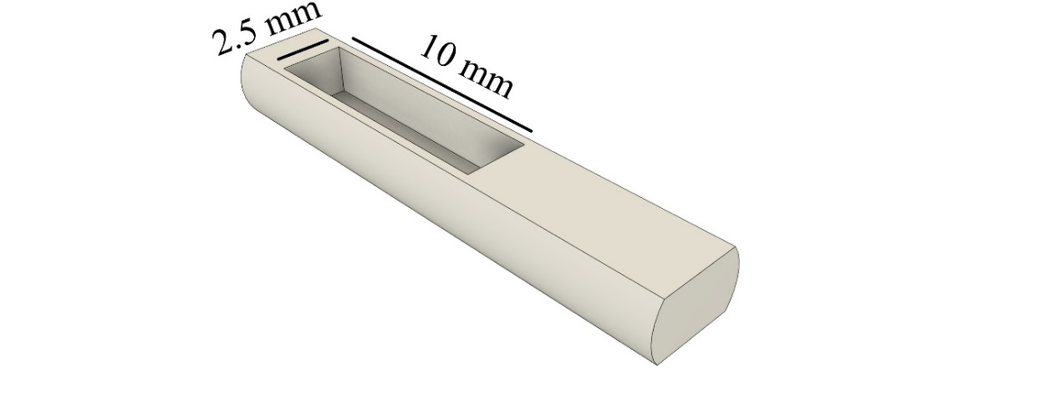

Figure S2. L-curve Tikhonov regularization parameter (alpha = 0.1) for lyogel in EtOH and BuAc with varied crosslinker concentration (0.007 – 0.050 g/g).
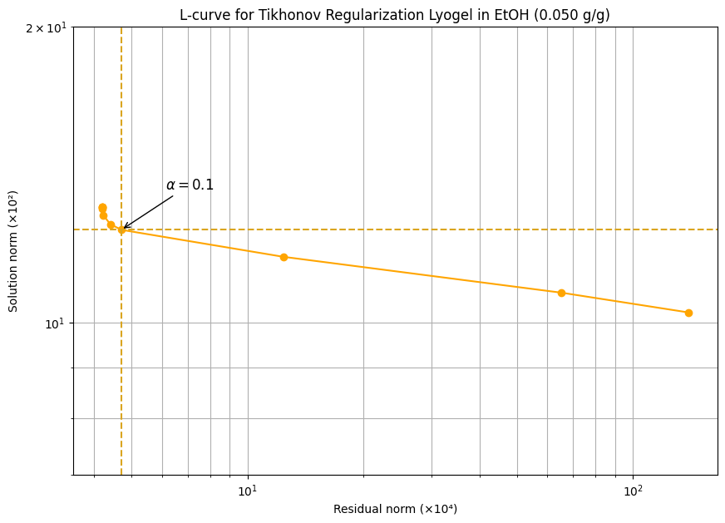
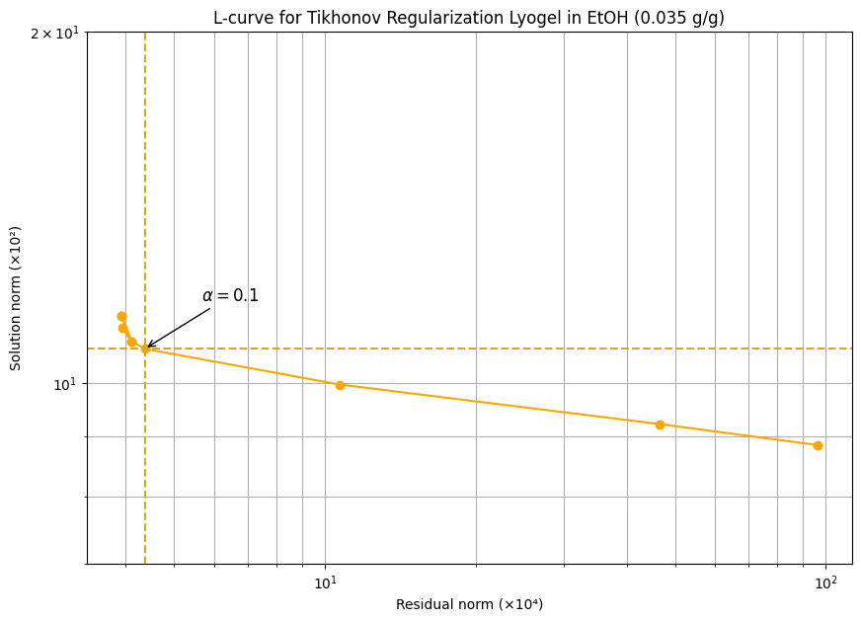
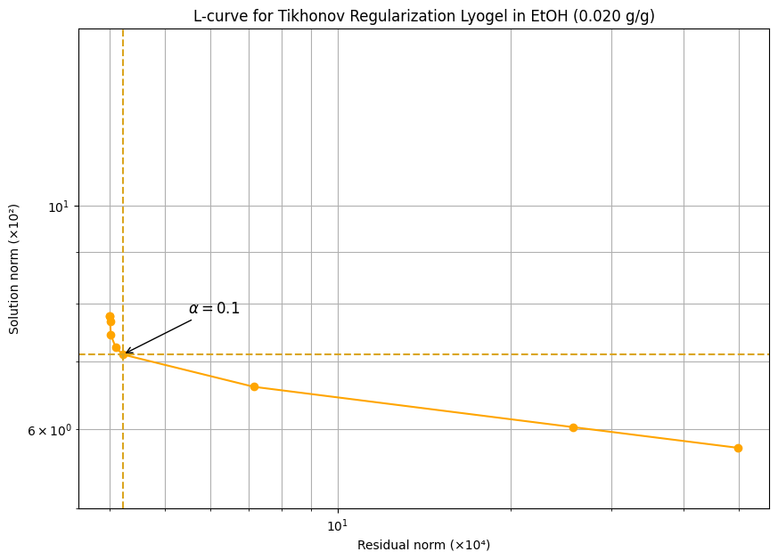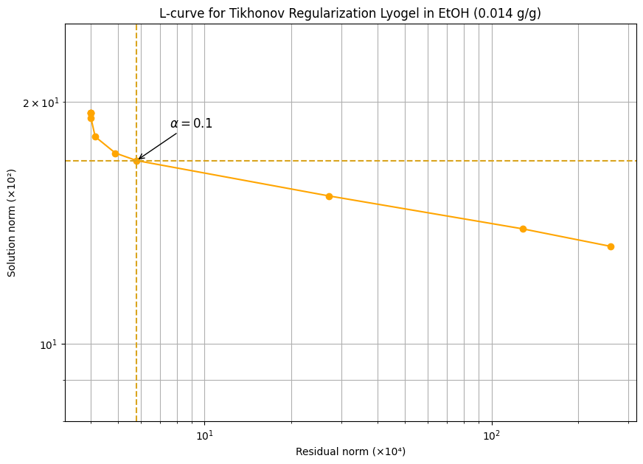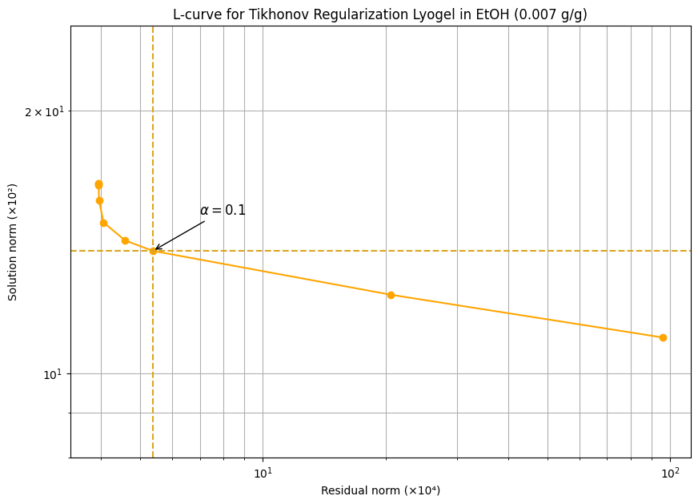

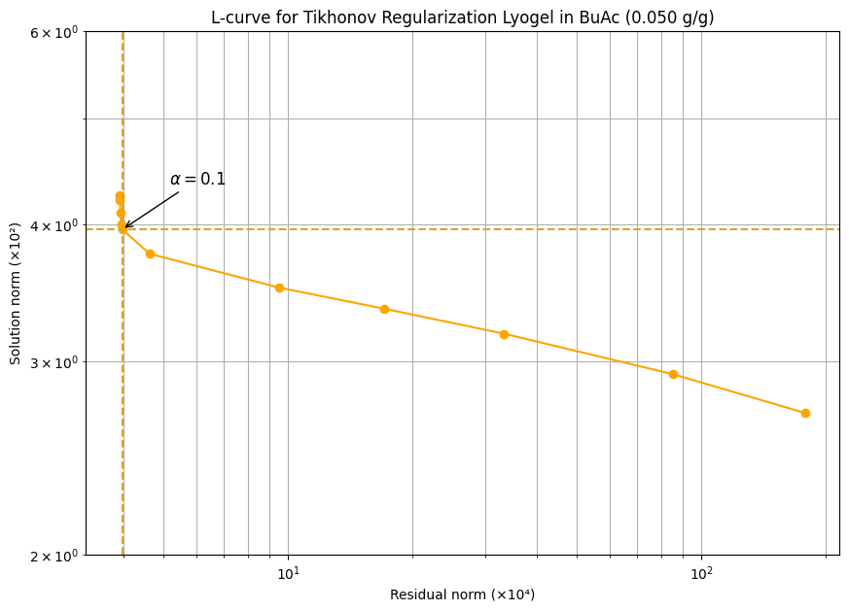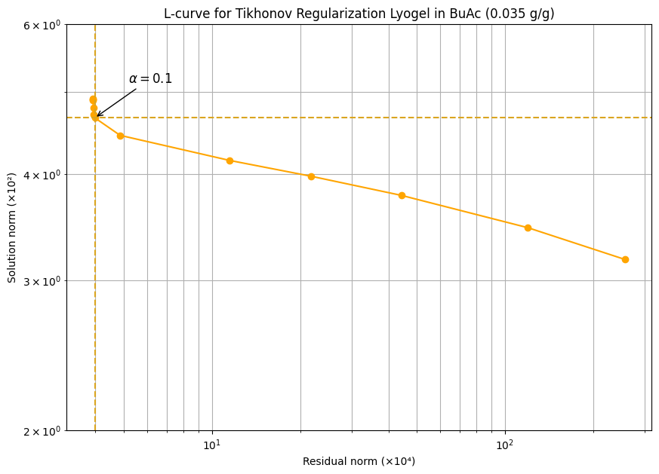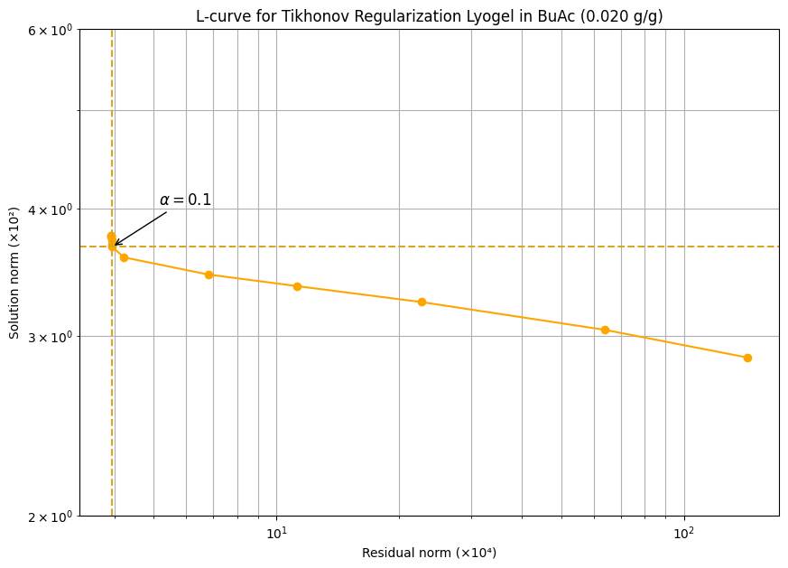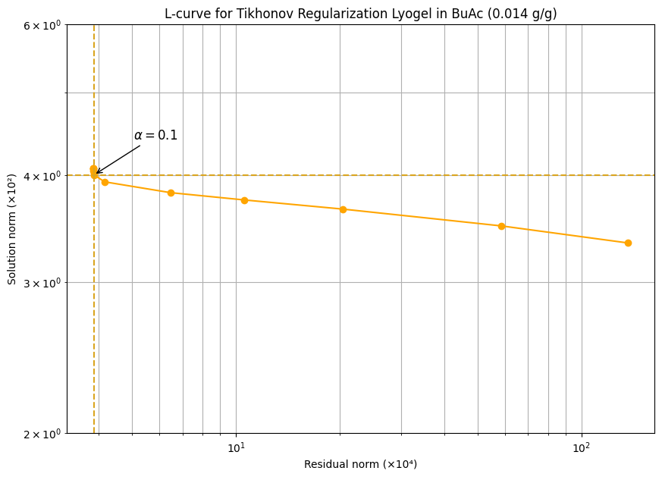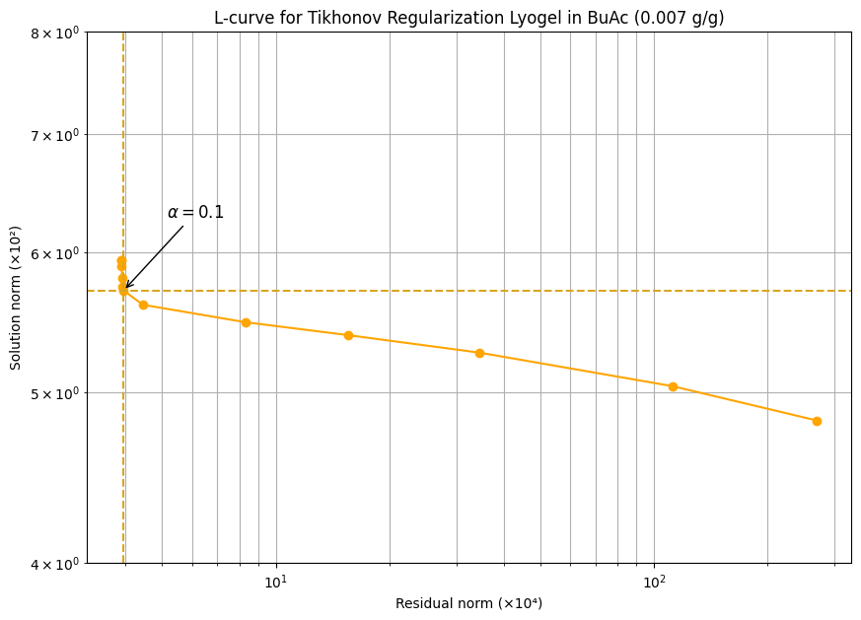

References
[1] Eckert KM, Müller S, Luinstra GA, Smirnova I. Exploring pNIPAM lyogels: Experimental study on swelling equilibria in various organic solvents and mixtures, supported by COSMO-RS analysis. Fluid Phase Equilibria. 2024 Nov 1;586:114182.
[2] Eckert KM, Bonsen J, Hajnal A, Gmeiner J, Hasse J, Adrian M, Karsten J, Kißling PA, Penn A, Fiedler B, Luinstra GA. Enhancing swelling kinetics of pNIPAM lyogels: The role of crosslinking, copolymerization, and solvent. Fluid Phase Equilibria. 2025 May 6:114462.

